Basics of MAC Addressing

Mac Adress:

1. Stands for Media Access Control
2. Every node in the LAN is identified with the help of MAC address
3. IP Address = Location of a person (Wherever the person goes their location change)
4. MAC Address = Name of the person (if location changes name doesn't change)
5. 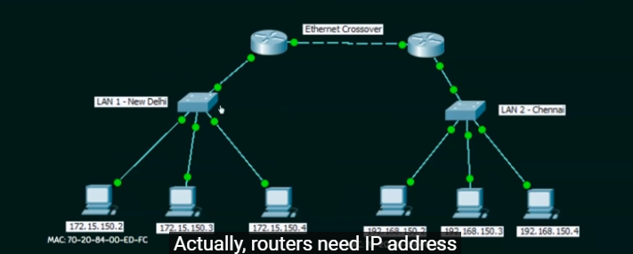
6. Routers(the one on the top) use IP address, Switches use MAC addresses.
7. Every switch will hold a mac address table so it knows where to forward the data.
8. Physical address or Hardware address
9. Unique in the world
10. Cannot be changed
11. Assigned by the manufacturer
12. Represented in hexadecimal
13. Example: 70-20-84-00-ED-FC (48 bits)
14. Separator: hyphen(-), period(.) and colon (:) → decided by the manufacturer.

IP vs MAC Address

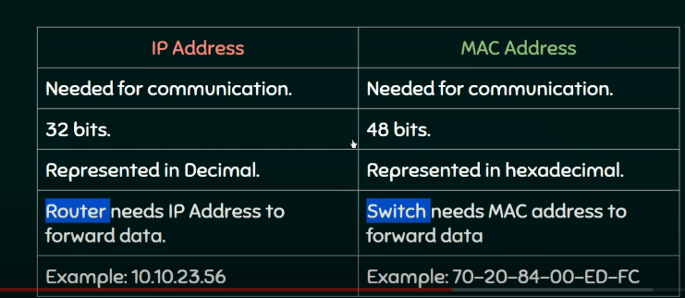

To see them in computer

IP adres: ipconfig

MAC: ipconfig/all